# Loki should be deployed prior to this; If monitoring the pod is not essential, it is fine.

1. Create a namespace to deploy experiment in that namespace

$ kubectl create namespace rpki

1. Deploy Quagga router pods

$ kubectl apply -f 1-um-sandbox-3.yaml

#What happened in this yaml file

#Submit a persistent volume claim (PVC) to request for a persistent volume to store configuration file

#Deploy a Kubernetes pod with 2 containers, quagga router and openvswitch

#openvswitch purpose is just for vxlan tunneling because quagga router image doesn’t allow to change VXLAN destination port (which blocked originally by underlying calico CNI)

1. Access quagga container

$ kubectl exec --stdin --tty -n rpki quagga-bgp-um-sandbox-3 -- /bin/bash

1. Copy daemons.txt and debian.conf from Pod yaml/Companion files into /etc/quagga/

#Because of using persistent volume to store the configuration file, the original files in the directory is wipe out during mounting the persistent volume, so we need to manually move the 2 files into the directory.

1. Run below initialization for the quagga software

$ chown quagga.quaggavty /etc/quagga/*.conf

$ chmod 640 /etc/quagga/*.conf

$ /etc/init.d/quagga start

1. Install ssh to access openvswitch container (this image only allows ssh access)

$ apt-get install ssh -y

$ ssh localhost

$ ovs-vsctl add-br switch

1. In openvswitch container, Point vxlan tunnel to other pod

$ ovs-vsctl add-port switch vxlan-um-sandbox -- set interface vxlan-um-sandbox type=vxlan \

options:remote_ip=10.144.227.165 options:dst_port=5566 #remote_ip = peer pod ip

$ ifconfig switch 192.168.100.7 netmask 255.255.255.0 up # vxlan interface ip address

1. In quagga container, configure promtail

$ cd /usr/local/bin

$ apt-get install nano curl -y

$ sudo curl -fSL -o promtail.gz "https://github.com/grafana/loki/releases/download/v1.6.1/promtail-linux-amd64.zip"

$ sudo gunzip promtail.gz

$ sudo chmod a+x promtail

$ sudo nano config-promtail.yml

1. Paste the following for promtail configuration

#config-promtail.yaml template https://sbcode.net/grafana/install-promtail-service/

server:

http_listen_port: 9080

grpc_listen_port: 0

positions:

filename: /tmp/positions.yaml

clients:

- url: http://loki:3100/loki/api/v1/push

scrape_configs:

- job_name: quagga

entry_parser: raw

static_configs:

- targets:

- localhost

labels:

job: quagga-um-sandbox-3

__path__: /etc/quagga/bgpd.log

1. Configure the Quagga router

$ telnet localhost 2605

#password quagga

# conf t

(config)> log file /etc/quagga/bgpd.log informational

#configure bgp peering; for example:

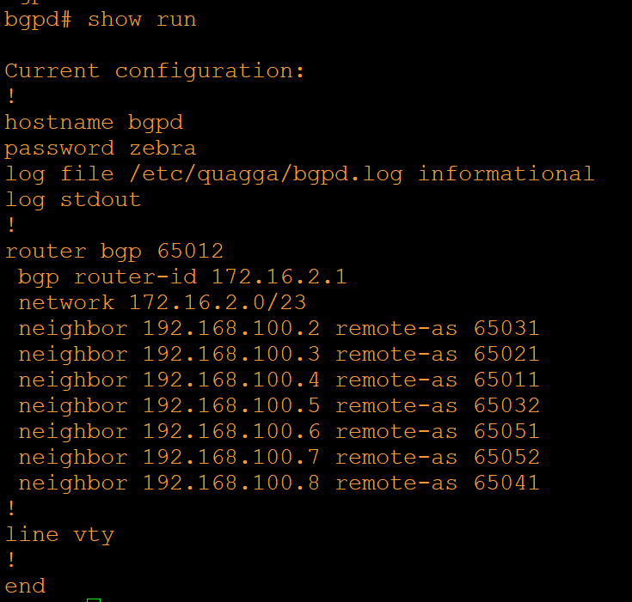

1. After configuring all router pods, check if the route received and installed in routing table. For example, network 172.16.0.0/23 and 172.16.4.0/23 are receiving from peers.

